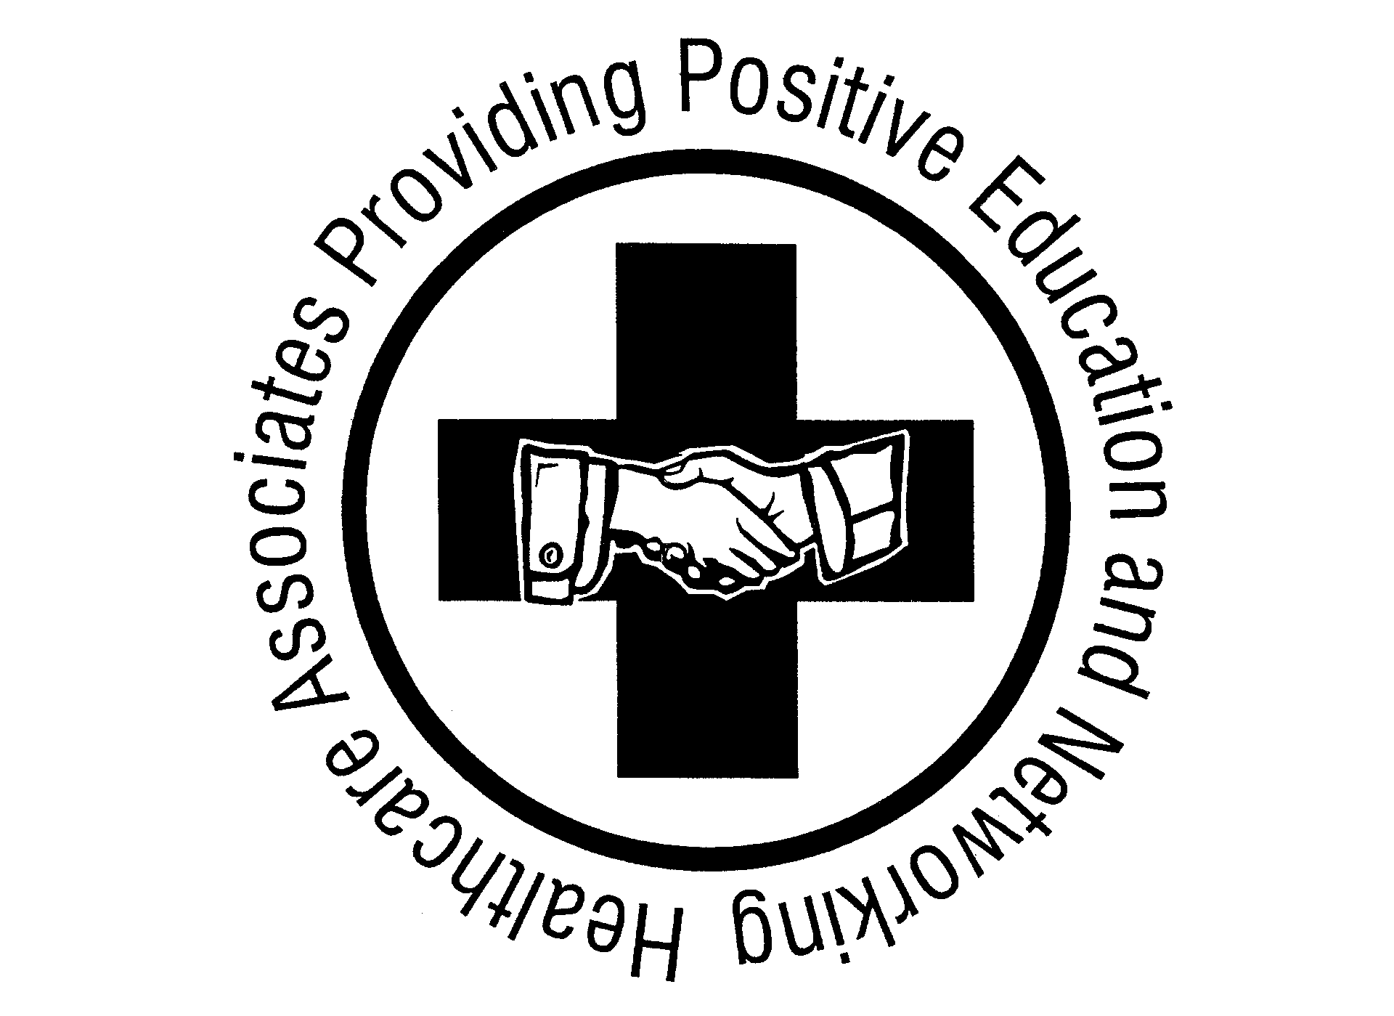
NOMINATE YOUR
“Caregiver of the Year”

Just a few minutes of your time could make a big difference in recognizing someone for their loving and professional talents.
Nominate CNAs or non-certified caregivers from your organization that you feel are individuals that go above and beyond their normal “job description” to provide professional and caring services to enhance the quality of their clients/patients lives for the 11th Annual “I Make It Happen” Caregiver of the Year Award.

Applicants to have these 5 qualifications – HEART, DEPENDABILITY, APPEARANCE, ACCOUNTABILITY, at least 1 YEAR OF EXPERIENCE as a caregiver*

Download the on-line application form at WWW.HAPPENidaho.com or request an e-mail form by contacting one of the individuals listed below.

The application MUST include:
- Your name, phone number, e-mail address
- Company name and address
- The nominee’s name, mailing address (to send invite to event), phone number, years of service with your company and whether they are a Certified Nursing Assistant or Personal Care Attendant
- Send in Microsoft “WORD” format. (Use specific form) – No pdf’s
- Current Photo of applicant for Program must be in (Jpeg or Bitmap format) - No pdf’s

Please submit your nomination in MS Word format Via E-mail to
Jolynn Hunt - Nominations Committee Member at jolynn@thecottages.biz
For more information call: Jolynn Hunt – Ph. 965-9106

Nominations must be received no later than April 25th, 2017
HAPPEN is a non-profit organization whose sole purpose is to provide positive education and networking to healthcare professionals in the Treasure Valley.
The winners will receive a cash award, plaque/certificate, and the honor of knowing that they are Treasure Valley’s finest caregivers. Only the finalists will receive a certificate of honorable mention, educational opportunities, special gifts, and a complimentary lunch ticket for themselves and a guest.

Help Us
“Make it HAPPEN”

Finalist awards to be presented on May 25th, 2017 at a special luncheon given in their honor at St. Alphonsus McCleary Center. Doors Open at 11:30am. Program starts at 12:00pm.
Visit us at HAPPENidaho.com
Application For
“I Make It HAPPEN”
Caregiver of the Year 2017
(Please make sure to include all of this information in the same format)

Candidate’s Full Name:
Is Nominee a CNA or PCA [Personal Care Attendant/non skilled]
Years of Service with your company:
Company Where Employed:
Company Address:
Nominee’s Phone Number:
Contact Person (Your name):
Phone Number (Your #):
E-mail (Your email):
DON’T FORGET THE PHOTOGRAPH!
Short essay as to why you think your candidate deserves this award: You have an amazing caregiver. Help us to get to know them as an individual so that we can see just how they shine. Use the prompts below as thought starters and write some specific examples/stories of how they helped a patient and what makes them your best caregiver. Please limit yourself to no more than one page typed.
- How do they go above and beyond normal duties? (Give us some specifics here like how they are an amazing problem solver, how they “spoil” their clients, how they show heart, dependability and accountability, etc.)
- Do you have customer testimonials from the families they help that you can share?
- Do you have comments from other employees that they work with that you can share?

*To assist you with the essay about your candidate, below is the scoring system the nominations committee will use.

_____ 50 points possible 1) Heart – passion for the job and going the extra mile for the patient;
_____ 20 points possible 2) Dependability – attendance and reliability;
_____ 15 points possible 3) Appearance – professional and appropriate;
_____ 10 points possible 4) Accountability – ethics, honesty, and responsibility
_____ 5 points possible 5) Longevity— at least 1 year of service with their current employer

See applicant rules and guidelines on page 3

Rules for “I Make it HAPPEN” Caregiver of the Year Award Application

- Applicants can be nominated subsequent years but once someone has won the award, they cannot be nominated again.
- The award is only for Certified Nursing Assistants and Personal Care Attendants. Medical Assistants, Nurses, Dietitians, or other healthcare professionals do not qualify.
- Essay entries cannot exceed one page typed.
- The award is for Professional Care Givers. Family members caring for individuals do not qualify.
- All nominees will be eligible to apply for available scholarship opportunities.
- Applications must be received by the application deadline date to qualify.
- Applicants must be US citizens.
- Applicants must have worked as a caregiver for at least 1 year.
- One nomination for each category per company.
- While we appreciate your nomination we must limit finalists to 12 PCA’s and 12 CNA’s. These individuals will be chosen by the committee and will receive recognition at the awards luncheon/ceremony. They will receive a free dinner ticket for them and 1 guest. Not everyone that is nominated will automatically become a finalist.

Thank you so much for taking the time to acknowledge others!

